**DAILY ONLINE ACTIVITIES SUMMARY**

|  |  |  |  |  |  |  |  |  |
| --- | --- | --- | --- | --- | --- | --- | --- | --- |
| **Date:** | **02/07/2020** | | | | | **Name:** | **Lavanya D M** | |
| **Sem & Sec** | **4th & ‘A’** | | | | | **USN:** | **4al18cs041** | |
| **Online Test Summary** | | | | | | | | |
| **Subject** | | **----** | | | | | | |
| **Max. Marks** | | **----** | | **Score** | | | **-----** | |
| **Certification Course Summary** | | | | | | | | |
| **Course** | EIGRP Course | | | | | | | |
| **Certificate Provider** | | | **Bitdegree** | | **Duration** | | | **1week** |
| **Coding Challenges** | | | | | | | | |
| **Problem Statement:**  1) Write a Java Program minimize the maximum difference between adjacent elements in an array 2) C++ program to print Left oriented right angled pyramid | | | | | | | | |
| **Status: Complied** | | | | | | | | |
| **Uploaded the report in Github** | | | | | **yes** | | | |
| **If yes Repository name** | | | | | <https://github.com/lavanyamurthi/lockdown-coding> | | | |
| **Uploaded the report in slack** | | | | | **yes** | | | |

Online Test Details: (Attach the snapshot and briefly write the report for the same)

No test conducted

Webinar:

Today class is conducted on C ++Programming by Shruthi Shetty ma’am in which we learn about the concept of C++ Programming, and even we had quiz regarding that

Certification Course Details: (Attach the snapshot and briefly write the report for the same)

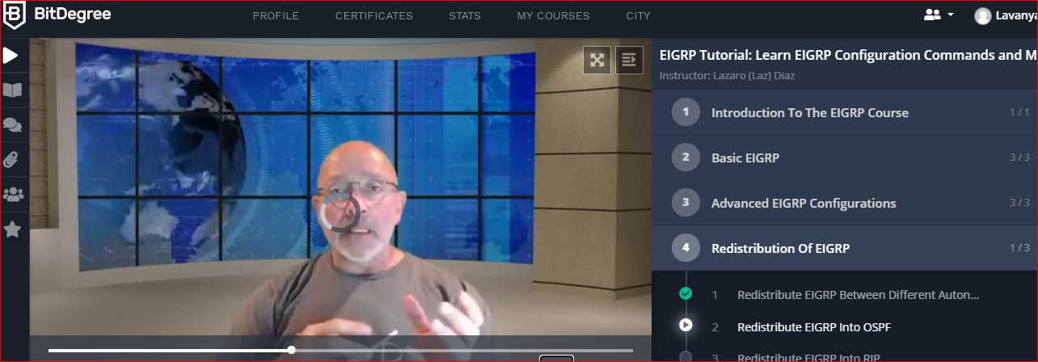

Coding Challenges Details: (Attach the snapshot and briefly write the report for the same)

**Problem 1 :** Write a Java Program minimize the maximum difference between adjacent elements in an array.

Given a non-decreasing array arr[] and an integer K, the task is to remove K elements from the array such that maximum difference between adjacent element is minimum.

Note: K < N – 2

Examples:

Input: arr[] = {3, 7, 8, 10, 14}, K = 2  
Output: 2  
Explanation:  
After removing elements A[0] and A[4],  
The maximum difference between adjacent elements is minimum.  
After removing elements, the remaining array is [7, 8, 10]

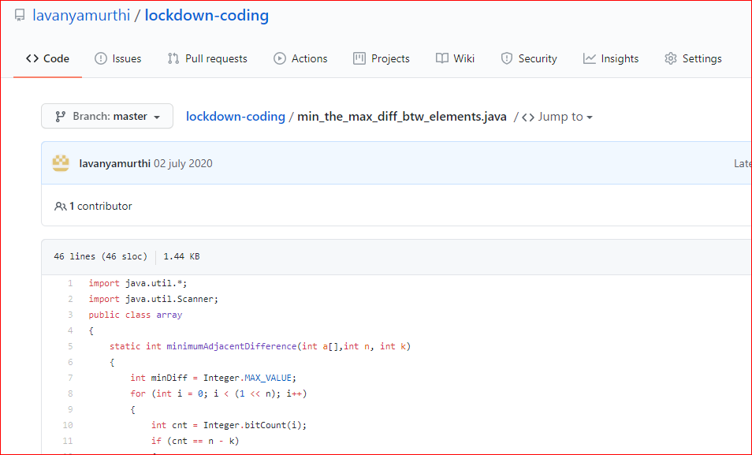

|  |
| --- |
|  |
|  |  |

# **Problem 2:**  **C++ program to print Left oriented right angled pyramid**

